

School of Electrical Engineering

DIGITAL ASSIGNMENT-1

BMAT202L - Probability and Statistics
Winter Semester 2025-2026

Name- Kushagra Papnai
Register No. 24BEE0171

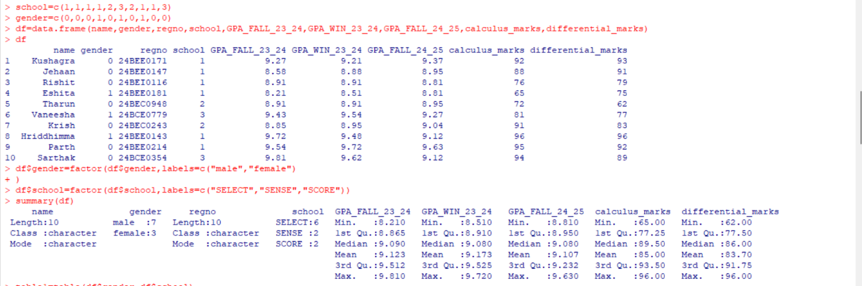
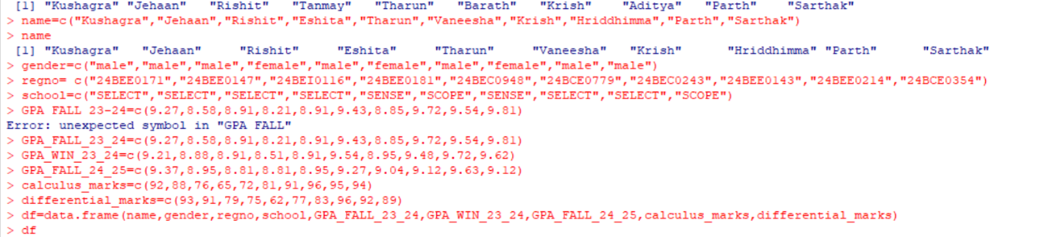
Give the summary statistics of the data set. Create a two-way table to understand the frequency distribution for Gender and School.

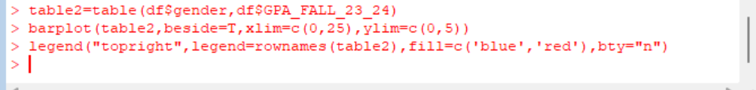
Use a histogram to visualize the GPA (for three semesters, separately).

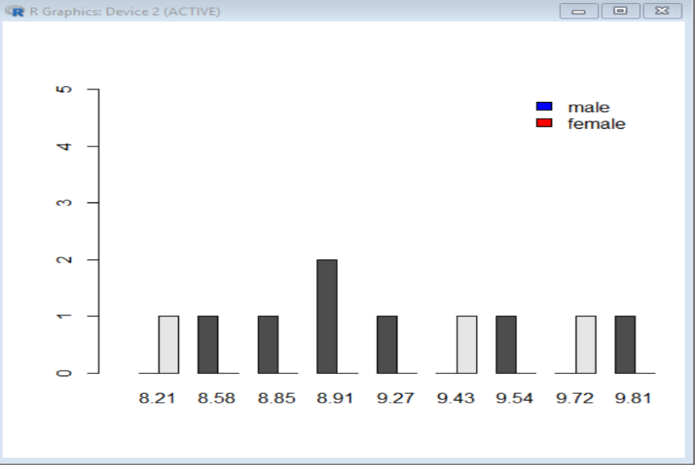

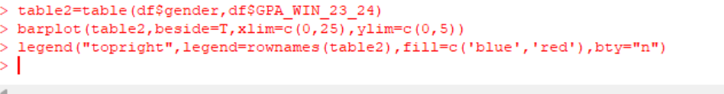
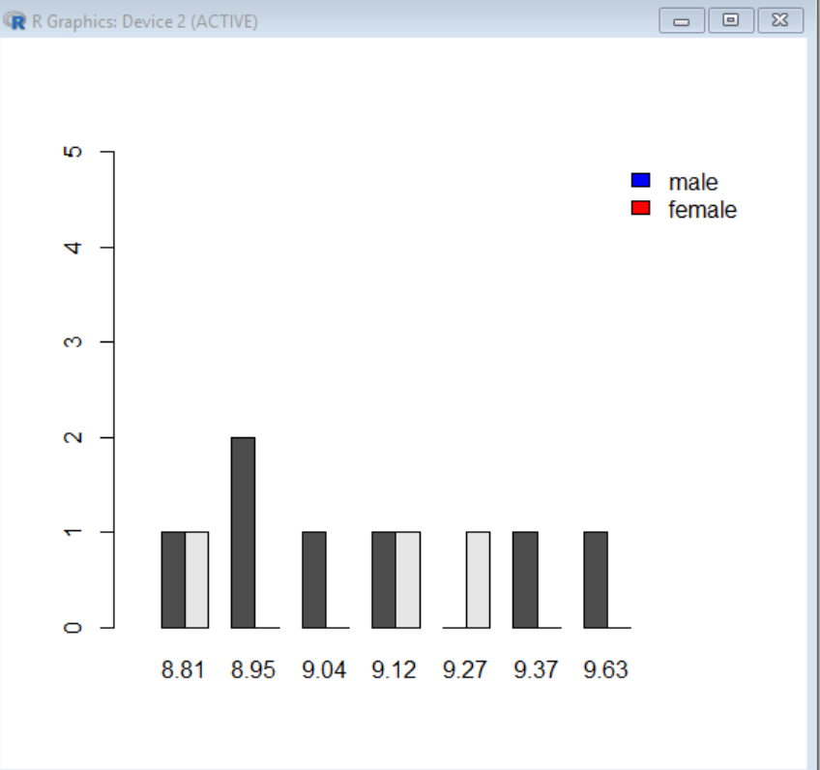
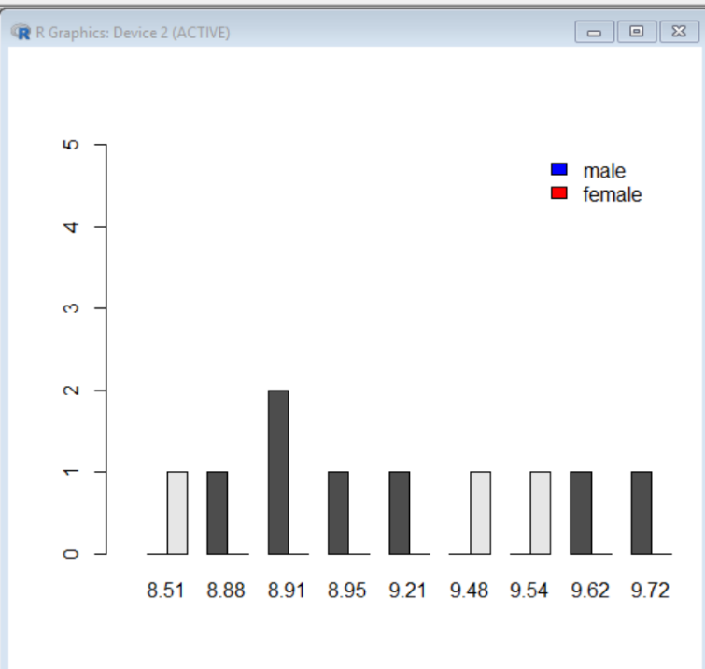
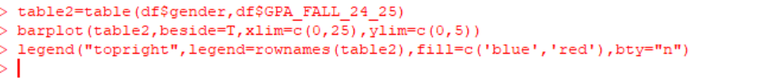

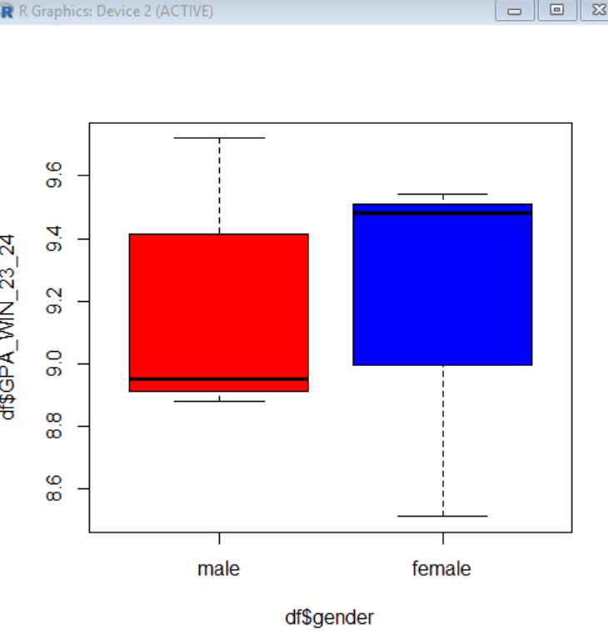
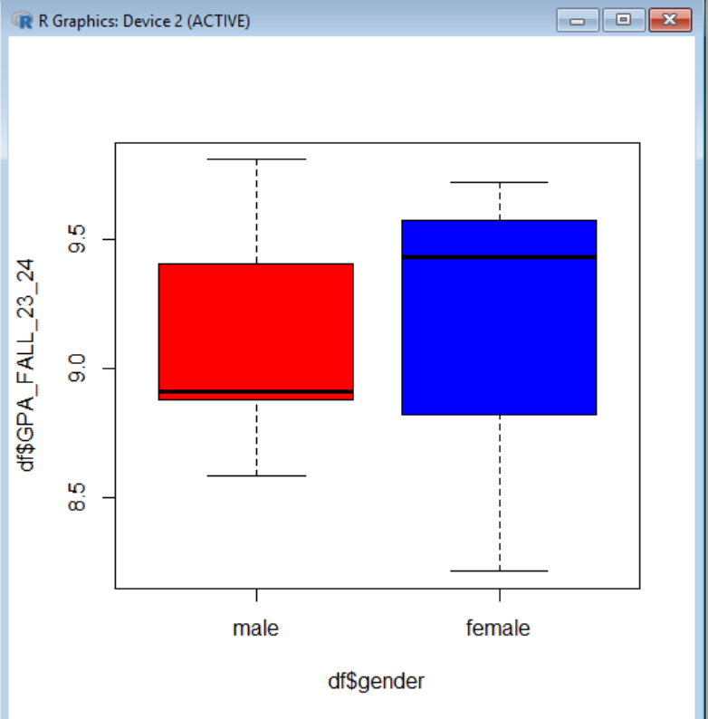
How do GPA scores vary by gender in the dataset? Plot a side-by-side box to compare the distributions of GPA scores between male and female students. (For three semesters, separately)

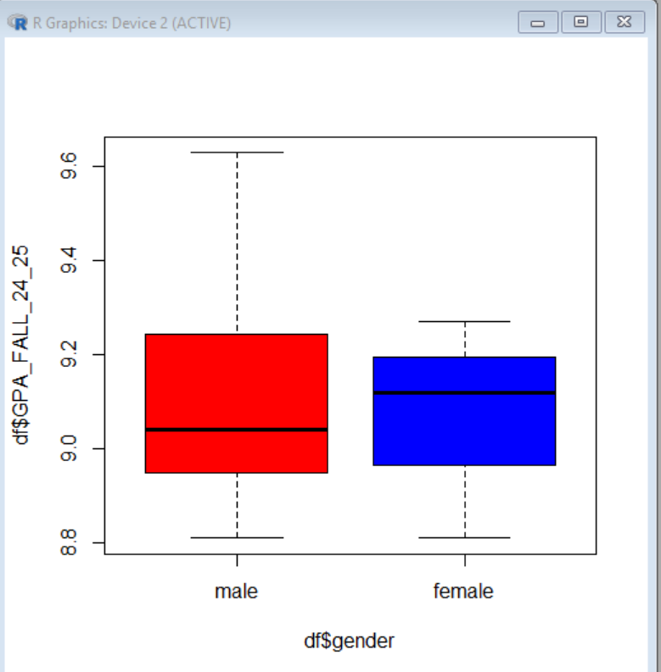

Create a pie chart to visualise the gender-wise percentage to get at least 8.5 GPA. (For three semesters, separately)
